Unemployment and Violent Crime Across U.S. States: A Data Analysis
Gabriel Ferrera & Andrew Lussier
MA 346 – Data Science

Executive Summary
This project examines whether there is a relationship between unemployment rates and violent crime across U.S. states. Using publicly available data from the U.S. Bureau of Labor Statistics and the FBI, the analysis combines state-level unemployment rates with violent crime rates for 2024 to explore how these two factors may be connected.
After merging the datasets and analyzing the results, a moderate positive relationship was identified, with a correlation of approximately 0.33. This suggests that states with higher unemployment rates tend to have somewhat higher levels of violent crime, although the relationship is not especially strong. A linear regression model supported this trend, showing a positive association between the two variables.
Overall, the findings indicate that while unemployment may be related to violent crime at a broad level, it is likely only one of many contributing factors. Additional variables and longer-term data would be needed to better understand the full relationship.

Objective
The objective is to explore whether there is a measurable relationship between unemployment rates and violent crime across U.S. states. While it is often assumed that higher unemployment may lead to increased crime, this analysis aims to evaluate that idea using real data rather than assumptions.
By comparing state-level unemployment rates with violent crime rates, this project seeks to determine whether a consistent pattern exists and to better understand how closely these two factors are related.

Data Sources
This project uses two publicly available datasets from reliable government sources. The first dataset was obtained from the U.S. Bureau of Labor Statistics (BLS) and provides unemployment rates by state for 2024. The second dataset comes from the Federal Bureau of Investigation (FBI) and includes violent crime rates by state for the same year.
These sources were selected because they are widely recognized for their accuracy and provide consistent, state-level data that aligns well with the objective of this analysis. Using official government data also helps ensure that the results are based on credible and trustworthy information.

Data Preparation
Before analysis, the two datasets needed to be aligned so they could be compared directly. Each dataset was organized at the state level, but formatting differences required adjustments to ensure consistency. State names were standardized across both datasets to allow for an accurate merge.
The datasets were then combined using state as the common variable, resulting in a single dataset that included both unemployment rates and violent crime rates for each state. This step was essential in enabling a direct comparison between the two variables.

Methodology
To examine the relationship between unemployment and violent crime, several analytical approaches were used. First, a scatter plot was created to visually assess the relationship between the two variables across states. This allowed for an initial understanding of whether any pattern or trend existed.
Next, a correlation analysis was performed to measure the strength and direction of the relationship between unemployment rates and violent crime rates. Finally, a simple linear regression model was used to further evaluate the relationship and determine whether changes in unemployment were associated with changes in violent crime.

Results
The relationship between unemployment rates and violent crime was first examined using a scatter plot. As shown in Figure 1, there is a general upward trend, indicating that states with higher unemployment rates tend to have higher levels of violent crime.
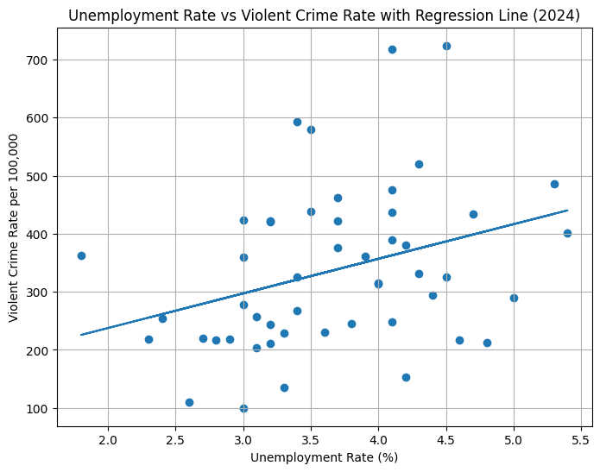
Figure 1: Scatter plot showing the relationship between unemployment rate and violent crime rate by state (2024), with fitted regression line.

To quantify this relationship, a correlation analysis was conducted, resulting in a correlation coefficient of approximately 0.33. This indicates a moderate positive relationship between the two variables, meaning that as unemployment increases, violent crime tends to increase as well, although the relationship is not particularly strong.
A linear regression model further supported this finding, showing a positive association between unemployment rates and violent crime. While the regression confirms the overall trend observed in the scatter plot, the variability in the data suggests that other factors likely also play a significant role in determining crime levels across states.

Key Takeaways
- There is a moderate positive relationship between unemployment rates and violent crime across U.S. states, with a correlation of approximately 0.33.
- States with higher unemployment rates tend to have somewhat higher levels of violent crime, although the relationship is not particularly strong.
- The results suggest that economic conditions may play a role in crime trends, but they do not fully explain differences across states.
- The combination of visual analysis and statistical methods provides consistent evidence of a positive association between the two variables.

Limitations and Next Steps
This analysis is based on data from a single year (2024), which limits the ability to observe trends over time. Additionally, many other factors that may influence violent crime, such as income levels, education, population density, and law enforcement practices, were not included in this model.
Future analysis could expand on this project by incorporating data from multiple years and including additional variables to better understand the factors that contribute to differences in crime rates across states. This would provide a more comprehensive view of the relationship and help determine whether the patterns observed here remain consistent over time.

